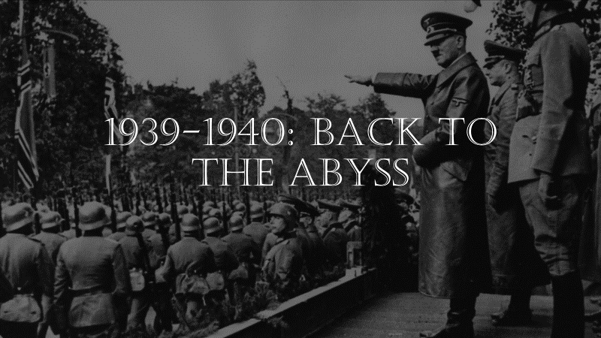
Name:__________________________________
Before September 1, 1939:
Axis Aggression
- -____________ had begun to subdue the __________ region ever since the end of WWI (Manchuria, Korea, etc.)
- -____________ had become staunchly fascist, and humiliated the League of Nations in the 1935___________________________.
- -_____________ had rebuilt, rearmed, and now proved a daunting threat to all of Europe. They annexed __________, took the __________________ (the north, west, and southern borderlands of Czechoslovakia), and eventually ALL of ___________________.

-Neville Chamberlain’s policy of “_________________” had failed.
-The __________________________________ and ____________________________ proved that Britain and France were on their own.
-On Sept. 1, 1939, _________________________________ War is on.
-___________________= “Lightning Warfare.”

1940—the Phoney War (AKA “Sitzkrieg”)
1940 is remembered as an uneventful year where very little fighting happened. But there were some key events:

- ___________________________
-The French refortified their border with Germany… ________.
-The Germans went around it… ________.
-With their new Blitzkrieg tactics, they soon overtook Paris in a little over a month on June 14, 1940.

-More bad news…

- ___________________________
-The British and French were ________________________________ by the Germans, who stopped just outside the town.
-Over _________________ troops were evacuated across the English Channel in a “Miracle of Deliverance”, many of them aboard civilian boats.
-They lost (abandoned) nearly all of their tanks, vehicles, and equipment, but they lived to fight another day.

- ___________________________
-With France fallen, Hitler planned an invasion of Britain, but to do this, he would need _______________________________.
-Germany began a large-scale bombardment of _______________________________ and—eventually—____________. The RAF struggled to fend them off.
-The campaign lasted months. At one point, Britain was bombed ____ nights in a row.
-This was the first major campaign in history fought entirely by ____________________.
The RAF was nearly wiped out, and __________ civilians were killed. But the British persevered.
-Dunkirk and the Battle of Britain showed that the British would not fall as easily as France had.
-Their fortitude—encouraged largely by the rousing speeches of _________________—impressed Britain’s allies, particularly America.

Across the Ocean…
-US President ___________________________ knew that a conquered Britain would be dangerous for the US. He began supplying aid to them through the ___________ policy.
-He wanted the US to be the “______________________________”

-Using America’s industrial might, he began shipping _____________________________
____________________________ to America’s allies so that they could continue to fight against the Axis:
-$31.4 billion to ______________ -$11.3 billion to _______________
-$3.2 billion to _______________ -$1.6 billion to ________________
-$2.6 billion to _______________

Canada’s Contribution—the British Commonwealth Air Training Program (BCATP)
-Canadian Prime Minister ______________________________ offered to build airports across Canada that would host and train vast numbers of Air Force pilots from across the British Commonwealth (Britain, Canada, Australia, New Zealand, India, South Africa, the Caribbean, etc.)
-Nearly half of the airmen from the British Commonwealth (both fighter pilots and bomber crews) were trained through this program.

