1941—The Year of Surprises.
Operation Barbarossa
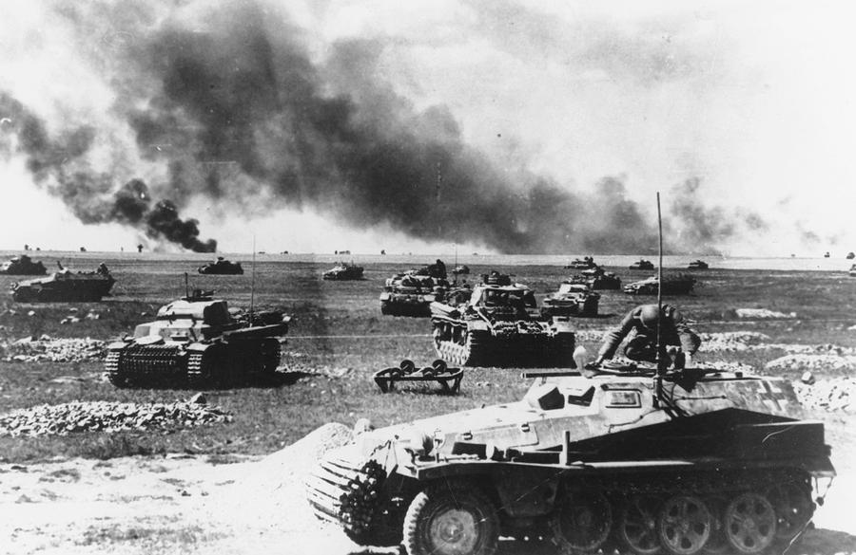
- What were Hitler’s reasons for wanting to invade the Soviet Union?

- Why was Russia ill-prepared for war?

- Which nations in southern Europe were Allied with Hitler? Which were Pro-British?

- Operation Barbarossa—How many men and aircraft did the Germans have?

- Who had more men and tanks? Who had superior technology and speed?

- What day did Operation Barbarossa begin?

- At Minsk, how many Russian prisoners were taken?

- How were Germans received in Ukraine, and why?

- How did Stalin react to Hitler’s betrayal?

- What was Churchill’s reaction?

Pearl Harbor
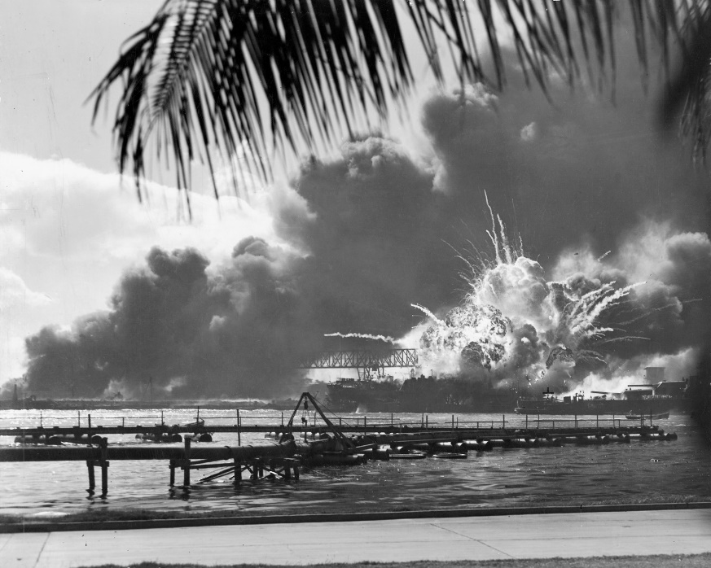
- What had been America’s response to Japanese expansionism?

- Japan’s two choices ____________________________________ or ___________________

- Out of 8 battle ships at Pearl Harbor, how many were sunk? ____________

- How many minutes did it take the Japanese to cripple the US Pacific Fleet? ________________

- Japan lost _____________ men, US lost __________________ men

- What were Japan’s 2 critical mistakes?

- The US was united for revenge by the attack on Pearl Harbor, but Washington predicts the war will cost _________ billion dollars. Half was raised through taxes. How did they raise the other half?

- Who declared war on the US 4 days after Pearl Harbor? _________________

- Which enemy does Roosevelt decide to focus on, and why?

