Bombing Ethics Project
Name:_________________________________
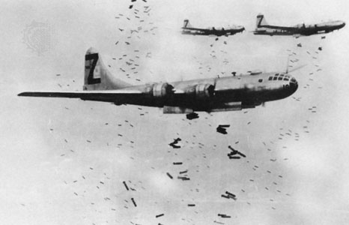
In large, lengthy conflicts, the Rules of Warfare tend to get disregarded, and the Second World War was certainly no exception. One of the most controversial theatres of warfare turned out to be the sky.
The Second World War took aerial bombardment to a whole new level as entire campaigns were fought from the air. However, many of these battles caused horrendous damage, and some have been labelled as atrocities—even war crimes.
This assignment deals with the Historical Thinking Concept of Ethics. Your mission is to select one of the bombing campaigns from the list below and investigate it. Find out:
-when did it happened?
-where did it happened?
-who was doing the bombing?
-who was being bombed?
-why was that location chosen for bombing (what was the goal?)
-what were the results of the bombing? (eg. number of casualties, damage to enemy morale, destroying enemy arms factories, bringing countries into the war, causing countries to surrender, etc.)

Using what you find, you must then play the part of a lawyer. Imagine that the nation(s) who committed this bombing is on trial. You must either defend or prosecute them, based on whether you think the bombing campaign was justifiable/ethical or not. For reference, I have attached a sheet containing a summary of the “Rules of Warfare [regarding] Aerial Bombardment.” Read it and highlight any sections that might pertain to the aerial campaign you researched. Use these in your write-up as evidence for why you think the bombing was justified or not. (YOU WILL NEED AT LEAST ONE DIRECT QUOTE FROM SOME SOURCE IN YOUR WRITE-UP).
Remember, laws and ethics are not always necessarily the same thing. If you believe there is a particular reason why the laws listed on the “Rules of Warfare” sheet should not apply to the bombing you researched, you may argue why.
Recap of requirement:
- Minimum 3 pages (double-spaced)
  - Explain the historical context of the bombing (who-what-when-where? At what point in the war did this bombing happen? What events had preceded/caused it to happen?) (5 points)
  - Explain the reason why that location was chosen to bomb, what the goal of the bombing was, and what the results were. (5 points)
  - Finish with a paragraph either defending this bombing as ethical/justifiable, or condemning it as unethical/unjustifiable. Use at least one direct quote from either the “Rules of Warfare” sheet or another source you used for research (NOT WIKIPEDIA) (10 points)
- A list of your sources (once again, NOT WIKIPEDIA).
-Don’t worry about APA citation for this one. Just the sources are fine.
The Bombings are…
-The London Blitz -Pearl Harbor
-The Firebombing of Hamburg -Rotterdam Blitz
-The Firebombing of Tokyo -V-1 and V-2 Rockets
-The Bombing of Dresden -The Doolittle Raid
-The Atomic bombing of Hiroshima and Nagasaki
-Another bombing of your choosing (Ask Mr. Duncan)

Rules of War

Aerial Warfare
Protection of civilian populations is also a primary concern of the rules governing aerial warfare. Indiscriminate bombing of undefended cities or other areas densely inhabited by civilians is considered a serious war crime. Aerial bombardment of private property that is unrelated to military operations, such as private homes, commercial establishments, philanthropic institutions, historical landmarks, and educational facilities, is also forbidden. Aerial assaults on hospitals, public or private, are banned as well.
The incidental destruction of private property during an aerial attack may not violate the rules of war, however, if the attack is carried out for military purposes. These include the interdiction of military communication and transportation, the enervation of military forces and installations, and the destruction of factories manufacturing arms or military supplies. Nonetheless, the bombing of such targets may be illegal if it endangers high concentrations of civilians, and the stated military objective is unclear or unimportant.
Aircraft must be identified by external markings to allow belligerents to distinguish military from civilian aerial units. Additionally, such markings allow neutral countries to identify their own aircraft and permit the peaceful entry of aerial medical units onto a battlefield. Regardless of the nature of an aerial unit, belligerents are prohibited from firing on persons parachuting from a disabled aircraft, unless they are paratroopers engaged in an ESPIONAGE mission. Distinguishing paratroopers from other parachutists is left to the discretion of individual pilots and gunners.

Source: https://law.jrank.org/pages/9960/Rules-War-Aerial-Warfare.html

